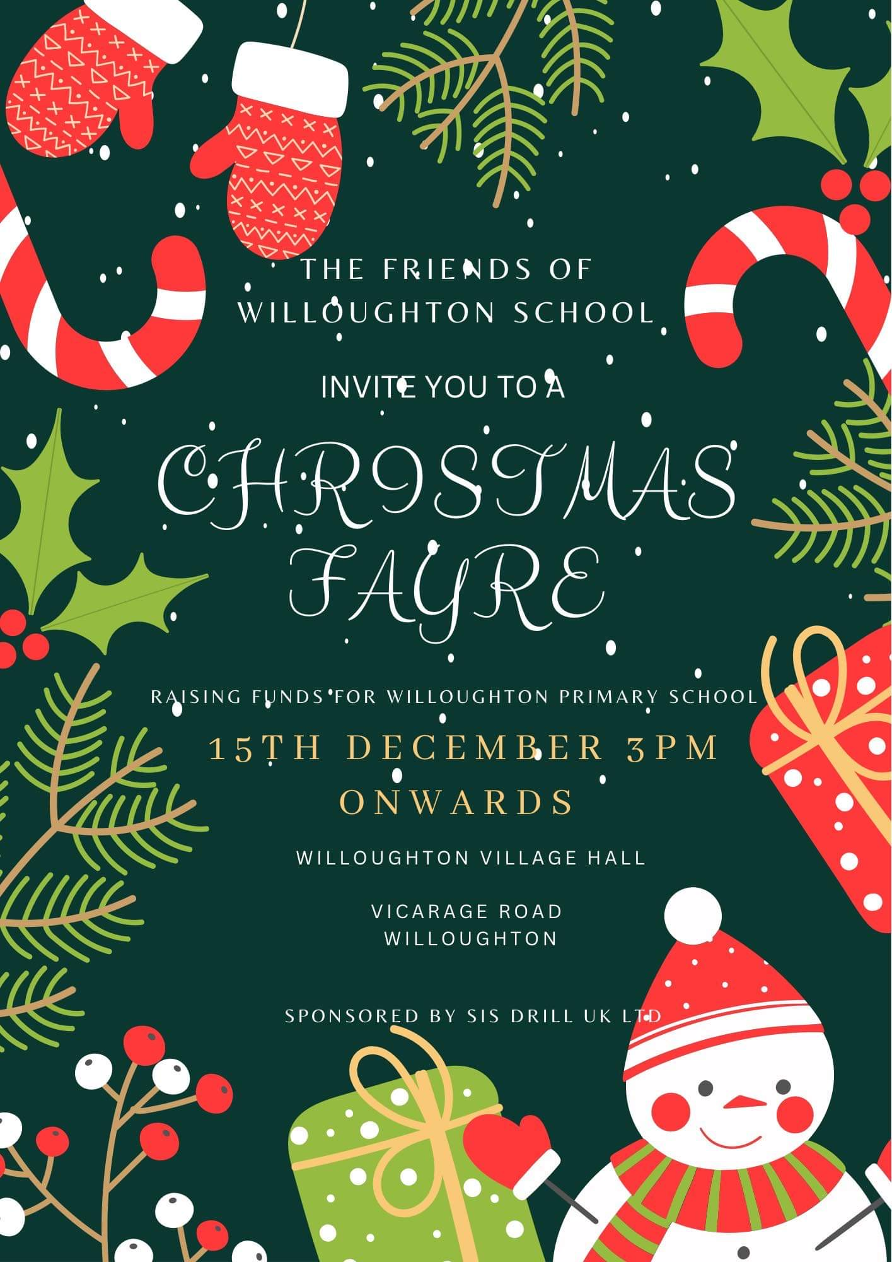

Thank you for your continued support. Your contributions will continue to make a difference to the children at Willoughton Primary School.



We are holding a Christmas Fayre at Willoughton Village Hall on the 15th December to raise funds for Willoughton Primary School.

We are also looking for donations for our tombola where we have had some lovely local businesses and members of the public donate already.

Some of our fantastic prizes are

⭐️ Full set of classic lashes by Lashes and brows by Linda

⭐️ Frenchic paint by Jacatata

⭐️ 2 hour clean by Dani Heap

⭐️ Lamination or Lash Lift worth £39 by Little Blue Beauty

⭐️ Wax melt and bath bomb hamper by Ickletickle Home Scents

⭐️ Products by Sensational Scents by Elaine

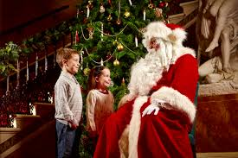We will also have a Santa’s Grotto which can be pre-booked for £2 per child. Your child/children will meet Santa, have a photo taken with him (parents to take the photo) and receive a gift. 🎅🏼🎁 All proceeds from the grotto will go to the school.

Children can also visit our Reindeer Food Bar to make some magical food ready for Christmas Eve!

Hot and cold refreshments will be available for a small donation.

I would like to pre-book my child/children to see Santa

Name _______________________________

Class ________________________________

I enclose £2 per child