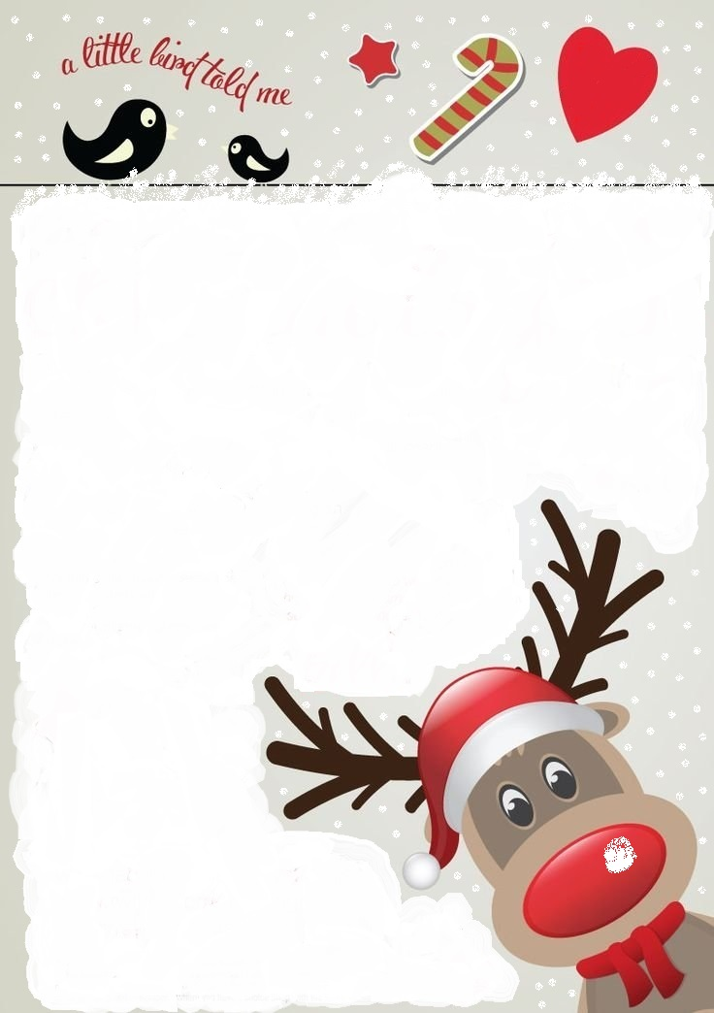

Thank you in anticipation of your co-operation and hopefully next Christmas things will be back to more like normal.

Best wishes,

Mrs Waplington

**Wednesday 16th December**

**Wear Christmas jumper/Christmas outfit**

**Christmas Celebrations in the afternoon with a quiz**

**Thursday 17th December**

**Elf virtual visit with a Christmas gift**

**Last day of term.**

**Christmas**

**Christmas at Willoughton with a difference in 2020**

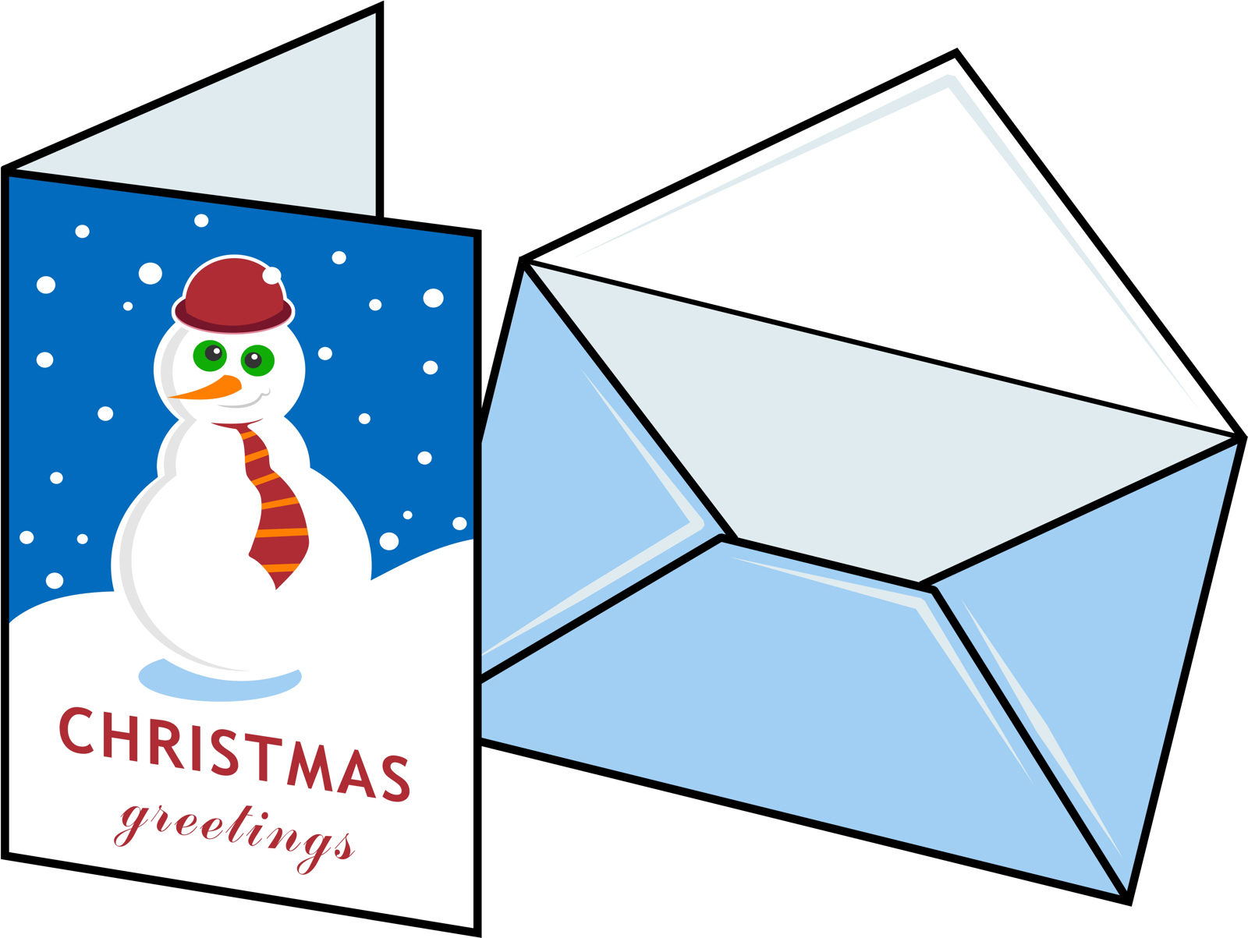

Dear Parents/Carers,

As you know, Christmas will be very different in school this year. Although we are restricted about what we can do because of the Coronavirus pandemic, we will, of course do our best to ensure it is still an enjoyable time in school for your children.

**The school posting box will be open from Tuesday December 1st until Thursday 10th December. All cards arriving in school after this date will be sent back home.** On Monday 14th December, school staff will empty the post box, sort out and deliver the cards. The cards will not be allowed to be opened at school – the children will bring the home with them.

**Willoughton Primary School**

The countdown has begun!