Just a little note to let you know what is happening before the end of term.

Thursday 11th July – Sports Day 1.45 pm
You are most welcome to come along and support us! Please could we ask that you bring chairs to sit on or a picnic blanket.

All children will be brought back to school after and released from school at their usual doors – the summer fayre will then start in the playground – please bring plenty of change to raise money for our school.

We look forward to seeing you!
Thursday 11th July – Summer Fayre 3.15 pm

Friday 12th July – Transition morning inc lunch

Tuesday 16th July – Reports going home

Wednesday 17th July – Drop in 3.15 – 4.15 pm for parents.

Thursday 18th July – Celebrations in the village – Winners of the Lincolnshire school challenge 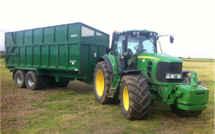 Time TBC

Friday 19th July – Leaver’s Service – 11 am 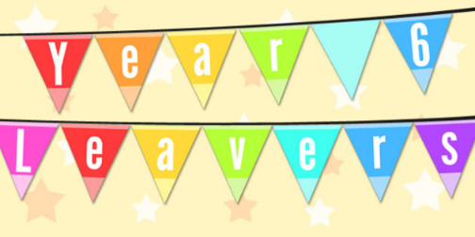

Friday 19th July – PM – Leaver’s picnic
Details to follow
Friday 19th July – End of Term 6

Have a great summer holiday!

