[](http://www.google.co.uk/url?sa=i&rct=j&q=&esrc=s&source=images&cd=&cad=rja&uact=8&ved=0CAcQjRxqFQoTCIWr2ZCFq8gCFUaGGgodt-8GdQ&url=http://littledumplingschildcarecenter.com/october-news/&psig=AFQjCNF8iuQ9iIWZONMIFK7xqT-A2C_YGg&ust=1444124488789366) NEWSLETTER

Dear Parents,

Can you believe we are nearly at the end of term 1?

I am really pleased to see that our new reception children have settled in well and the children that have moved up a year group are working hard too. Please remember if you wish to discuss anything my door is always open.

Thank you Mrs Lees.

Great News!

As you will see APRIL has now joined us in school and on our new website.

Our Vision Statement:

Our aim is to provide a broad, rich, diverse and creative curriculum that allows children to become independent, aspirational and resilient learners who have acquired a life-long love of learning and take pride in everything they do.

Aspirational

Pride

Resilience

Independence

Love of learning

 Tuesday 31st October

The FOWS have organised a dress up for Halloween day in school for £1 each. Please remember that children should wear suitable costumes for school. NO weapons are allowed.

***Breakfast Club***

Breakfast club is working very well in school and we thank Miss Ramsay and Mrs Cowell for their continued commitment. If you would like your child to attend breakfast club, please ensure that you complete a breakfast club form on the Friday for the following week. Payment of £1 per day is required. This enables us to confirm numbers for the following week. Please do not just turn up with your child if they are not booked in.

For Health & Safety and insurance purposes it is important we have a register of attendance.

Thank you

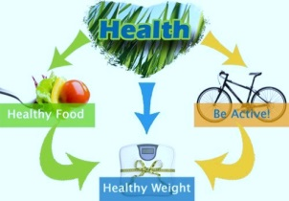 ***KEEPING FIT AND HEALTHY***

Preparing your child's lunchbox

A balanced packed lunch should contain:

* starchy foods – these are bread, rice, potatoes, pasta and others
* protein foods – including meat, fish, eggs, beans and others
* a dairy item – this could be cheese or a yoghurt
* vegetables or salad and a portion of fruit
* no fizzy drinks

Starchy foods are a good source of energy and should make up a third of the lunchbox. But don't let things get boring.

Some options are: instead of sandwiches, give kids bagels, pitta bread, wraps and baguettes. Use brown, wholemeal or seeded bread, not white bread.

Please ensure your child brings a healthy lunch box to school. No chocolate bars or sweets are allowed. If you would like some further advise check out the website:

[www.nhs.uk/Change4Life](http://www.nhs.uk/Change4Life)

Did you know that whenever you buy anything online - from your weekly shop to your annual holiday - you could be collecting free donations for Willoughton Primary School - Gainsborough?

There are over 3,000 shops and sites on board ready to make a donation, including Amazon, John Lewis, Aviva, thetrainline and Sainsbury's – it doesn't cost you a penny extra!

It's as easy as 1, 2, 3...

1. Head to https://www.easyfundraising.org.uk/causes/willoughtonprimary/ and join for free.

2. Every time you shop online, go to easyfundraising first to find the site you want and start shopping.

3. After you’ve checked out, that retailer will make a donation to your good cause for no extra cost whatsoever!

There are no catches or hidden charges and Willoughton Primary School - Gainsborough will be really grateful for your donations. Thank you for your support!

 

Christmas Cards

Thank you for returning the Christmas cards. They have now been sent off.



We are taking part in Operation Christmas Child, filling shoe boxes to help children less fortunate than ourselves. Please return to school by Monday 20th November (AM)

Thank you for your support.

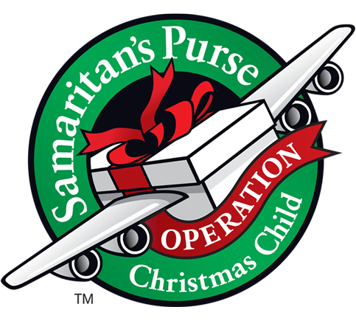

Macmillan Cake sale!

Thank you to everyone who donated cakes for the stall. We raised £169.44.

A big thank you.





**School Uniform and PE Kit**

We encourage pride and a sense of ‘belonging’ at Willoughton School by asking pupils to wear a school uniform, including appropriate footwear and PE kit and would appreciate your support in ensuring that the agreed uniform is worn to school. Please also help us to avoid too much ‘lost property’ by naming all items of school clothing.

Thank you

**P.E kits should be brought to school and left in school until school sends them home.**

**SCHOOL SHOES**

**School footwear**

Some children are not wearing appropriate school shoes for school. Please can we ask that black shoes are worn to school. Boots, canvas shoes or trainers are not permitted.