

Welcome back to school.

Tennis will continue until Christmas every Wednesday morning at breakfast club.

7.45 – 8.45am. 

Dates to remember.



Remembrance Service 2pm on Friday 11th November at St.Andrew’s Church.



After school clubs starting

W/c 7/11/16

Choir club – Tue 3.15 – 4pm KS1 and KS2

Sports club – Thu 3.15 – 4.15pm KS1 and KS2

Letter to follow.

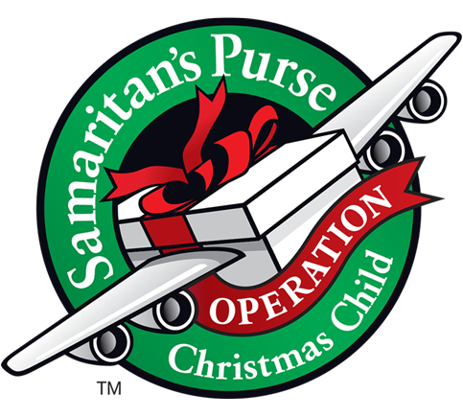Shoe box collection

If you would like to help support a Christmas child, they will be collecting on Monday 21st November.

 Christmas Nativity

2pm and 6pm on Monday 19th December.

Letter to follow.

Children in Need Day

Thursday 17th November

Wear Yellow for day! If you would like to donate some cakes, we would be grateful.

Tuesday 20th December

End of Term 2

It’s Christmas!



Christingle Service

Our Christingle service will be on Tuesday 20th December 2pm at St. Andrew’s Church.

 Swimming finishes at school on Friday 16th December.

 Pantomime trip

We are off to the pantomime on Wednesday 14th December.

Letter to follow.

 Christmas lunch is on Tuesday 6th December.

Please look out for the menu!