Welcome back after half term. We hope you had a lovely week enjoying the weather.
Here is a recap of the fabulous work we have been doing at Willoughton!
To kick start the New Year we took part in Young Voices! The children, staff and parents thoroughly enjoyed the whole event, there was lots of dancing and singing. We look forward to this again next year!

Then we started swimming, the children were really enthusiastic and couldn’t wait to get in the water. It is amazing to see the confidence from the children.

Off to gymnastics we go, what a great experience to take the children to a gymnasium and learn safely how to use the equipment. The children are enjoying the apparatus and gaining confidence in themselves. I’m sure Class 3 will enjoy it in term 4.

We then had our Sports for Champions morning with Katie Stainton. It was inspiring for the children to meet her and engage in activities. We had a great morning and through your kind sponsorships we helped raise £342.00.
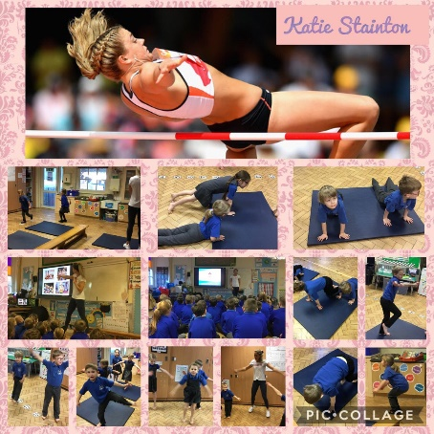

Class 3 then went on their travels to the Mosque and Lincoln City Football ground.
To start off our trip, we visited Lincoln Central Mosque. First, we learnt about the parts of a Mosque and what we might find inside before having a look around. The children behaved beautifully and asked some fantastic questions!
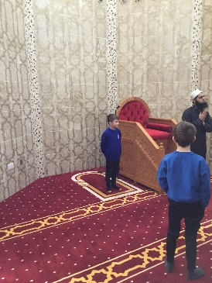
For the second part of our trip, we ventured to Sincil Bank Stadium- Home of the Imps! We all had the opportunity to tour the stadium and take part in some football related games! The children really impressed us with their skills!

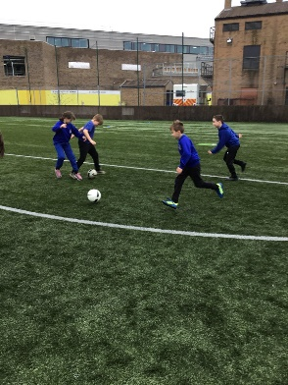

Class 1 then had a very interesting day!
What a morning for Acorns! We have had the pleasure of meeting Steve, a palaeontologist from DinoStar who came to talk to the children and share some amazing finds! We also had the opportunity to make our own fossils. Thank you very much Steve for a fantastic morning.

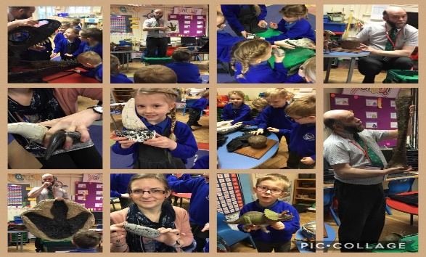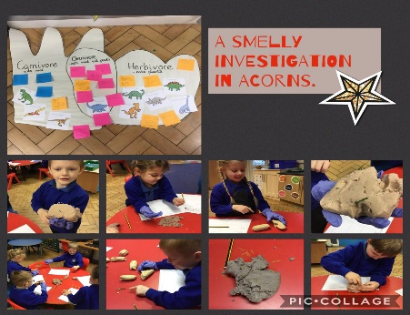

Class 2 then had a visit from Mr Griffiths to share information about Judaism.
This morning the Sapling Class were joined by Mr Griffiths who shared lots of interesting information about his faith; Judaism.
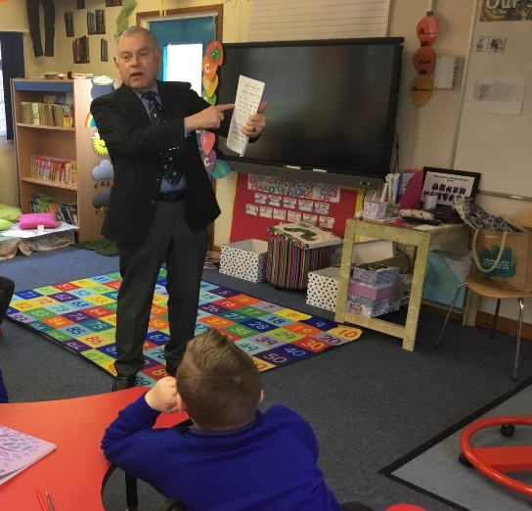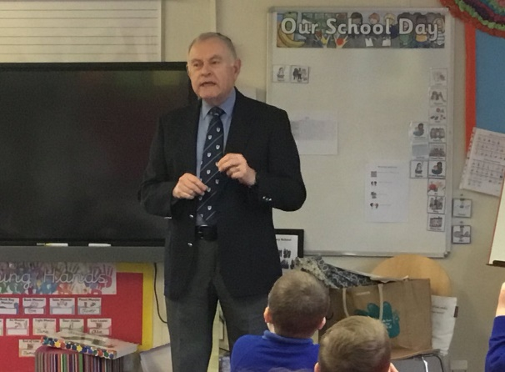

And finally to end this great term Cupid arrived. It was a special moment that we celebrated how much we all care for each other. Thank you to the FOWS for organising this.
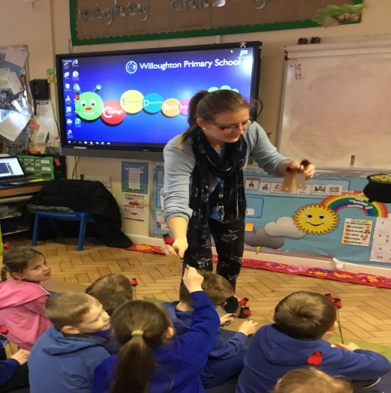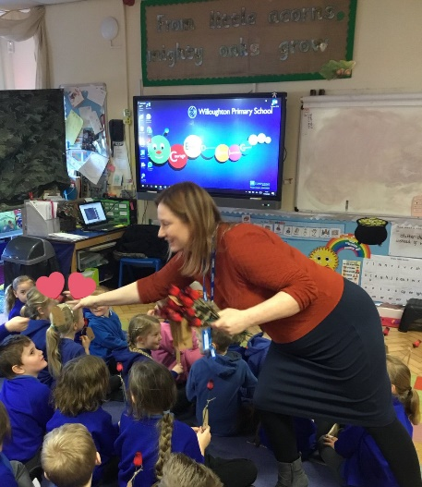

News for Term 4
Staffing
Following careful consideration, Miss Shakesby has decided to leave her position as Teaching Assistant and Midday Supervisor at this school due to personal reasons. This took effect on 31st January 2019. This has been accepted by the Governing Body, who would like to wish Miss Shakesby well for the future.
As of 11th March 2018, we will welcome Mrs Newman, a fully qualified teaching assistant, to the team at Willoughton. Mrs Newman will work as a support assistant in Class 1 on Mondays, Tuesdays and Fridays. As your children may have informed you, we now have two midday supervisors: Mrs Goodhand and Mrs Gillon - both ladies are also gaining experience in classrooms in preparation for teaching assistant training. We look forward to them joining our team at Willoughton. Mrs Hodgkinson continues to work as a support assistant in class 1 on Tuesdays, Wednesdays and Fridays, and Mrs Vale is based in class 3 on a full-time basis.
Don’t forget….
World Book Day on Thursday 7th March 2019
Red Nose Day Thursday 14th March 2019 – Noses are selling fast!

